**Department of Computer Science and Engineering**

|  |  |
| --- | --- |
| **Course Code: CSE 321** | **Credits: 1.5** |
| **Course Name: Operating Systems** | **Semester: Fall 18** |

**Lab 05  
CPU Scheduling**

1. **Overview:**

**CPU scheduling** is a process which allows one process to use the **CPU** while the execution of another process is on hold(in waiting state) due to unavailability of any resource like I/O etc, thereby making full use of **CPU**. The aim of **CPU scheduling** is to make the system efficient, fast and fair.. In this lab students will learn the concept of CPU Scheduling and Implement the different Scheduling Algorithm.

1. **Lesson Fit:**

Programming knowledge is required for this lab.

1. **Learning Outcome:**

After this lab, students will know the how Different Scheduling Algorithm works, be able to Scheduling using multiple processes.

1. **Anticipated Challenges and Possible Solutions**
   1. When interaction occurs among processes, sorting, loop condition, variable problems arise.

**Solutions:** Students should have the knowledge about previous algorithm labs.

1. **Acceptance and Evaluation**

Students will show their progress as they complete each task. They will be marked according to their lab performance.

**Activity Detail**

* 1. **Hour: 1  
     Discussion:**

1. Discussion on Non-Preemptive Priority Scheduling. Why CPU scheduling is important and its benefits
2. Will give some clue how to implement the algorithm in java programing .
3. Discussion on calculating the Waiting and Turnaround time for each process.
   1. **Hour: 2**
4. Discussion on Preemptive Priority CPU Scheduling.
5. Make an Example to implement the concept of Preemptive priority scheduling.
   1. **Hour: 3**
6. Discussion on Round Robin Scheduling Algorithm.
7. Importance and Complexity of Round Robin Algorithm.
8. **Home tasks**

Create 10 processes with different Burst time and Arrival time Priority and Quant time (Round Robin). Then implement the Preemptive, Non-preemptive and Round Robin scheduling algorithm. Calculate Response time, Turnaround time, waiting time and find which scheduling algorithm is best for the given data.

**Lab Activity List**

**Task 1 –(Non-Preemptive Priority Scheduling Algorithm)**

Here, suppose all processes arrive at the same time and the processes are arranged in order of their increasing priority time. Check for incoming processes after the completion of the current process.

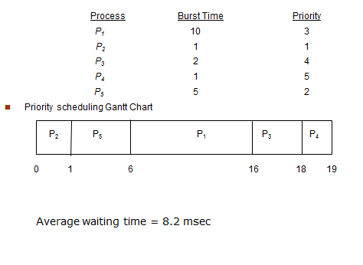

**Task 2 –(Preemptive Priority Scheduling Algorithm)**

For the previous process calculate Average waiting time for preemptive Priority Scheduling.

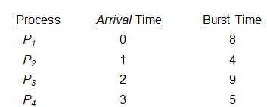

**Task 3–(Round Robin Scheduling algorithm)**

Create three processes with given Burst time. Calculate average waiting time for the RR where quant time is 4.After completing the task add different Arrival time for processes.

